Experiment – 10

Create a Virtual Hard Disk and allocate the storage using Vmware Workstation.
AIM:
To create and allocate a virtual hard disk using VMware Workstation.
SOFTWARE REQUIRED:
VMware Workstation 17, Ubuntu ISO, Host OS: Windows
PROCEDURE:
1.Start VMware Workstation 17 from the Start menu to open the virtualization platform on the host computer.
2.Create a new virtual machine by selecting the option to create a new VM and choose the “Typical (recommended)” setup to proceed with a standard configuration.
3.Select the operating system installation source by choosing the installer disc image file (ISO) option, then browse and select the Ubuntu ISO file required for installation.
4.Provide a suitable name such as “Virtual Machine Ex-14” for the virtual machine and choose an appropriate storage location on the host system before continuing.
5.Configure the virtual hard disk by accessing the Hard Disk settings and setting the disk capacity to 10 GB to allocate storage space for the Ubuntu operating system.
6.Complete the virtual machine setup by clicking Finish, after which the Ubuntu installation process is prepared to begin.
7.Save the configuration and power on the virtual machine by clicking OK, allowing Ubuntu to start installing automatically.

IMPLEMENTATION:



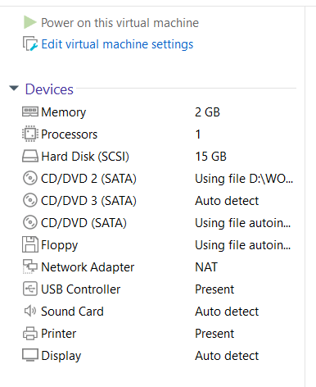
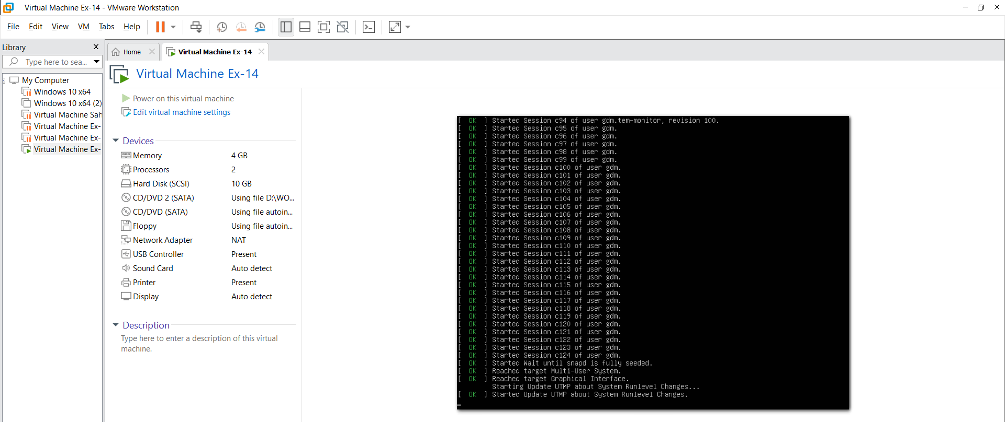

RESULT:
A virtual hard disk has been successfully created and properly allocated with the specified storage capacity, ensuring sufficient space for the installation and operation of the guest operating system.

